BAB 5 PURCHASE INVOICE
- MENU PURCHASE INVOICE
Penerimaan invoice sebagai realisasi dari Purchase Order.
No | Langkah-Langkah | Gambar
1 | Klik menu InpuData > Purchase Invoice | 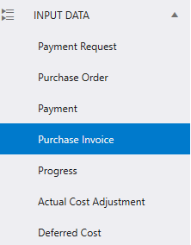
2 | Tampilan menu Purchase Invoice, Overview dan Purchase Invoice Data.
 | 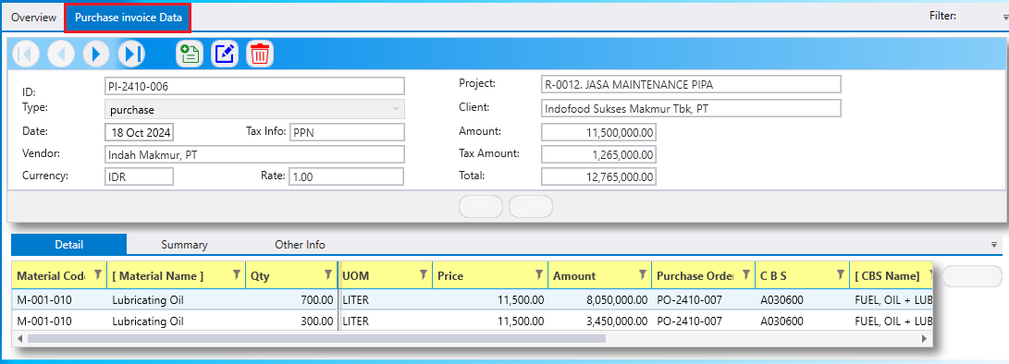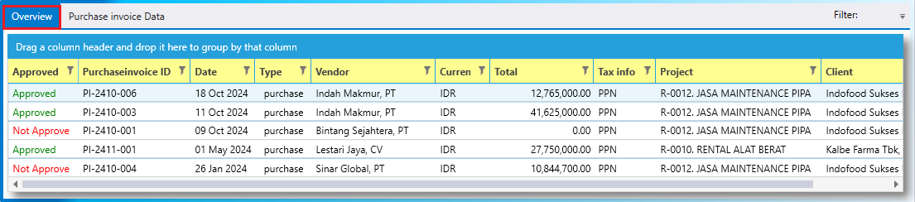

- CARA INPUT DAN EDIT DATA

